PRESS RELEASE 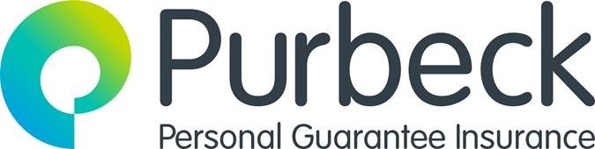

The number of small business owners who took insurance to guard against failure in 2022, hits new high

- Applications for personal guarantee insurance up 106% in Q4 2022 and 145% for 2022 on 2021
- Working capital top reason for new funding, applications up 144% in 2022 on 2021
- Huge 181% rise in applications for cover on loans £25-£50k year on year
January 2023: Personal guarantee insurance (PGI), a product used by small business owners to protect against the risk of a personal guarantee being called in for a business loan, saw a steep rise in popularity in 2022 as the owners and directors of some of the U.K.’s smaller, limited businesses, took on new finance that put their personal assets at risk. Lenders will ask for a personal guarantee when there are not enough assets in the business to repay the loan if the business fails.
Purbeck Personal Guarantee Insurance saw applications for protection more than double, rising by 106% in Q4 2022 vs Q4 2021. Across the whole of 2022, applications for personal guarantee insurance rose 145% on 2021 underlining the personal risks many small business owners have accepted in the past year to keep their businesses from insolvency.
Personal guarantee insurance has proved to be particularly popular amongst the owners and directors of smaller manufacturing businesses where there has been a 285% increase in applications for PGI in Q4 2022, compared to the same period in 2021.
The biggest reason for personal guarantee backed finance is ‘working capital’ with 35% of insurance applications for this reason. Year on year, the volume of personal guarantee backed finance for working capital grew 144% on 2021. In addition, asset purchase, typically for new equipment or machinery doubled in volume year on year.
In Q4 2022, most loans being taken out were between £75k and £100k in value but looking at the whole of 2022, the biggest year on year increase has been for much smaller loans from £25k-£50k in value, which jumped by 181%.
Todd Davison, MD of Purbeck Personal Guarantee Insurance said: “We know small businesses are facing huge cost challenges as they try to recover from the pandemic and problems with access to the finance they need to continue operating. Our latest PGI monitor shows that where loans are being made available, the owner is needing to take on a big chunk of risk themselves and a rapidly growing number are therefore taking steps to protect their personal assets should their business fail. We must not forget, business owners are not only facing increasing costs at work, they are keeping the wolf from the door at home too, it therefore makes perfect sense that they are doing what they can to bring some certainty in very uncertain times.”

Notes to Editors
About Purbeck Insurance Services
Purbeck Insurance Services is a Personal Guarantee Insurance specialist supporting Small and Medium sized Enterprises ("SMEs") and promoting business confidence
Insurance policies backed by Markel International Insurance Company Limited ("Markel"), an A-Rated insurer, as rated by A.M. Best (A), Fitch (A+) and S&P (A). Markel is a shareholder in Purbeck Insurance Services.
Purbeck Insurance Services is directly authorised and regulated by the Financial Conduct Authority
Insurance is underwritten by Purbeck Insurance Services, an authorised Managing General Agent ("MGA") of Markel
Purbeck Personal Guarantee Insurance is annual insurance policy that provides Director(s) with insurance cover in the event their business lender calls in the Personal Guarantee (provided by the Director(s) as part of raising business finance)
Key features of Personal Guarantee Insurance:
- Premiums are competitively priced and based on individual circumstances
- Cover is available for Personal Guarantees signed to support a wide range of business finance facilities
For further media information please contact Alison Reeson at HSL on 07876 597466, or purbeck@harrisonsadler.com.

